Lecture 2.2.3
Group, Homomorphism

Course outcome to be covered:
CO1: Apply and recognized about the Group, Homomorphism

Group
A monoid with inverse element is known as a group. The inverse element I, is the element of the set S such that (aοI)=(Iοa)=a, for each of the element a∈S. It can be said that four properties can be hold by the group – Closure, Associative, Identity and Inverse. The number of elements in the group G is represented by the order of the group G.
Examples
Under the operation of matrix multiplication, the set of N×N non-singular matrices form a group.
Closure property holds true as the product of two N×N non-singular matrices is also an N×N non-singular matrix, thus holding true the associative property.
The set of N×N non-singular matrices contains the identity matrix holding the identity element property.
As all the matrices are non-singular they all have inverse elements which are also nonsingular matrices. Hence, inverse property also holds.

Abelian Group
A group for which the element pair (a,b)∈G always holds commutative is known as abelian group G, thus holding true five properties – Closure, associative, identity, inverse and commutative.
Example
The set of positive integers (including zero) with addition operation is an abelian group. G={0,1,2,3,…}
Here closure property holds as for every pair (a,b)∈S,(a+b) is present in the set S.
For example, 1+2=2∈S and so on
Associative property also holds for every element a,b,c∈S,(a+b)+c=a+(b+c)
For example, (1+2)+3=1+(2+3)=6
Identity property also holds for every element a∈S,(a×e)=a
For example, (2×1)=2,(3×1)=3. Here, identity element is 1.
Commutative property also holds for every element a∈S,(a×b)=(b×a)
For example, (2×3)=(3×2)=3

Cyclic Group and Subgroup
A group that is generated by using a single element is known as cyclic group. Cyclic group is considered as the power for some of the specific element of the group which is known as a generator. The generator ‘g’ helps in generating a cyclic group such that the other element of the group is written as power of the generator ‘g’.
Example
The set of complex numbers {1,−1,i,−i} under multiplication operation is a cyclic group.
There are two generators − i and –i as i1=i,i2=−1,i3=−i,i4=1 and also (–i)1=−i,(–i)2=−1,(–i)3=i,(–i)4=1 such that it covers all the elements of the group thus forming a cyclic group.
Note – Every cyclic group is an abelian group but not every abelian group is a cyclic group.
If the four properties (Closure, associative, identity and Inverse) are simultaneously satisfied by the subgroup H then it will be a subset of the group G, represented as H≤G.
A subgroup H of a group G that does not include the whole group G is called a proper subgroup (Denoted by H<G). A subgroup of a cyclic group is cyclic and a abelian subgroup is also abelian.
Example
Let a group G={1,i,−1,−i}
Then some subgroups are H1={1},H2={1,−1}
This is not a subgroup − H3={1,i} because that (i)−1=−i is not in H3

Partially Ordered Set (POSET)
An ordered set which has a binary relation that is transitive, reflexive and antisymmetric is a partially ordered set which is represented as POSET.
Examples
The set of real numbers under binary operation less than or equal to (≤) is a POSET.
set S={1,2,3} and the operation is ≤
The relations will be {(1,1),(2,2),(3,3),(1,2),(1,3),(2,3)}
This relation R is reflexive as {(1,1),(2,2),(3,3)}∈R
This relation R is anti-symmetric, as
{(1,2),(1,3),(2,3)}∈R and {(1,2),(1,3),(2,3)}∉R
This relation R is also transitive as {(1,2),(2,3),(1,3)}∈R.
Hence, it is a POSET.
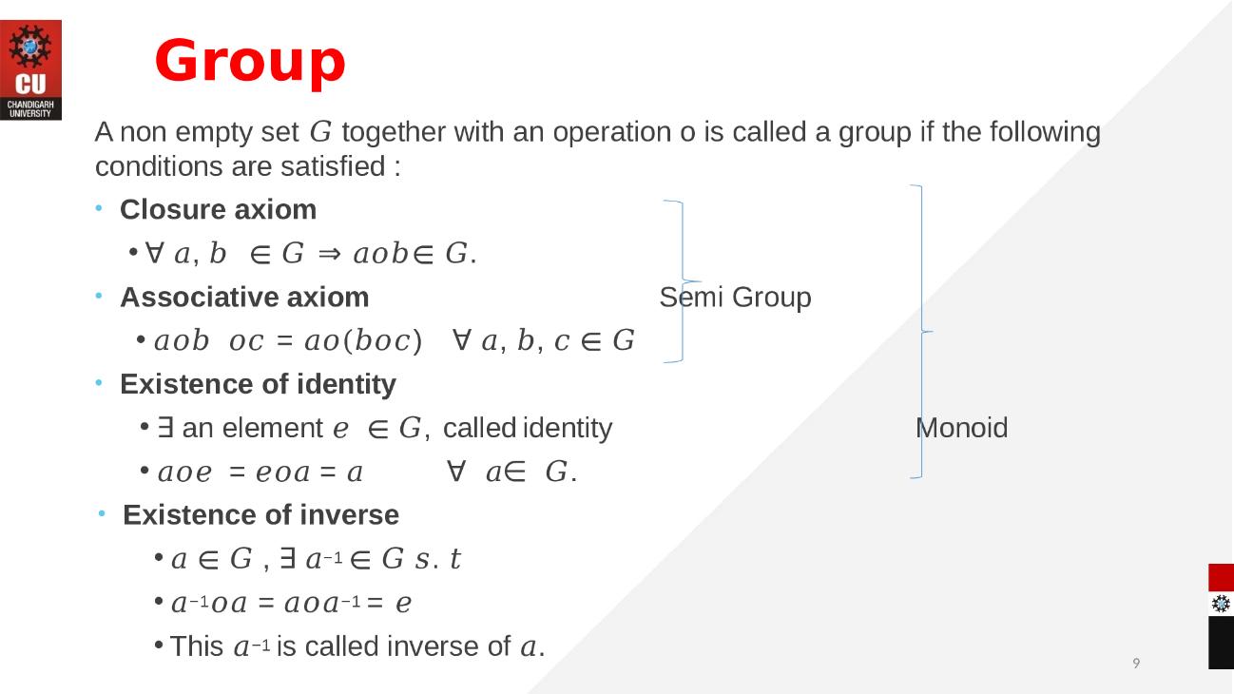

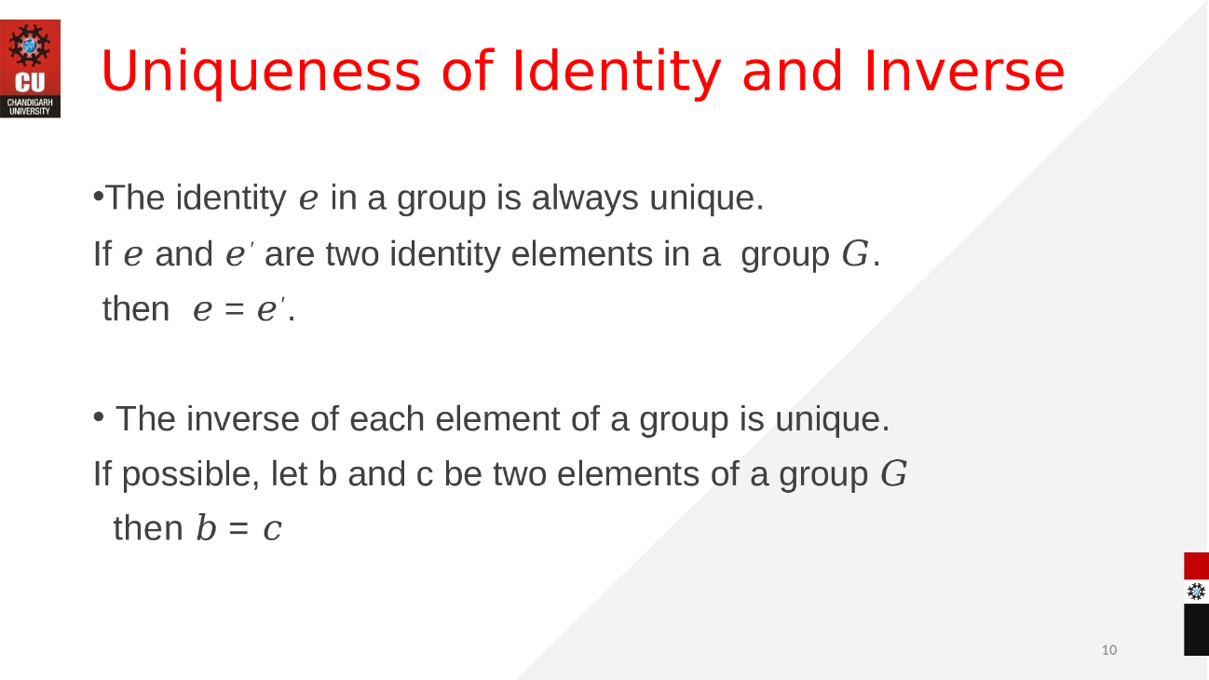



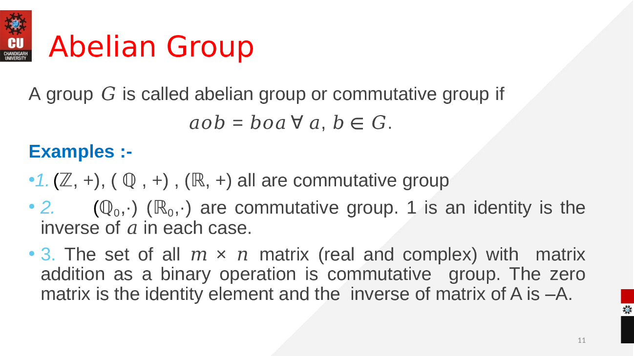
Homomorphism
Homomorphisms are the maps between algebraic objects. There are two main types: group homomorphisms and ring homomorphisms. (Other examples include vector space homomorphisms, which are generally called linear maps, as well as homomorphisms of modules and homomorphisms of algebras.)
A homomorphism between two algebraic objects A,B is a function f:A→B which preserves the algebraic structure on A and B. That is, if elements in A satisfy some algebraic equation involving addition or multiplication, their images in B satisfy the same algebraic equation. The details of the definitions of homomorphisms in various contexts depend on the algebraic structures of A and B.
Example
If the operations on A and B are both addition, then the homomorphism condition is f(a+b) = f(a)+f(b).
f(a+b)=f(a)+f(b). If A and B are both rings, with addition and multiplication, there is also a multiplicative condition: f(ab) = f(a)f(b).

eBook Discrete Mathematics :
https://www.ucl.ac.uk/~ucahmto/0007/_book/4-8-homomorphisms-and-isomorphisms.html

Video link: https://www.youtube.com/watch?v=XPF5fe1WdKY

